Title: GUESS THE NUMBER GAME
Description:
The “Guess the Number Game” is a simple Java-based interactive game in which the system randomly generates a number within a predefined range, and the player attempts to guess it within a limited number of attempts. The program provides hints such as “Too High” or “Too Low,” helping the user approach the correct answer. The project demonstrates the use of Java fundamentals such as random number generation, conditional statements, loops, and user-input handling. This game increases logical thinking and showcases how interactive console applications can be developed using Java.
Block diagram:
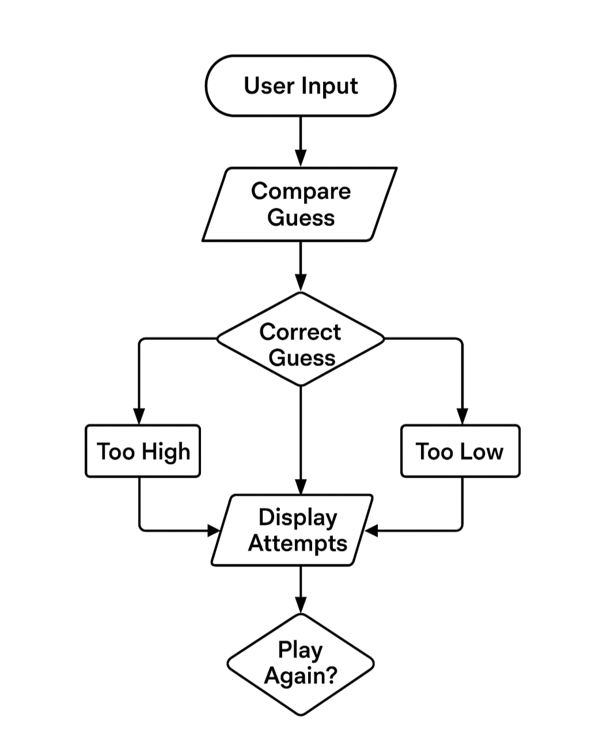

Figure 1.1 Block Diagram

OUTPUT:





